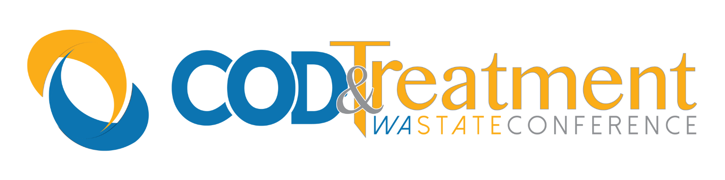

2026 Washington State Co-Occurring Disorders and Treatment Conference Exemplary Service Awards

Thank you for your interest in nominating a professional or volunteer for the 2026 exemplary service awards. We know that you are busy, and tried to keep the application short, while collecting important information about the nominees. Nominations are due by close of business September 18, 2026 and awardees will be notified via email by Thursday September 24, 2026.

Goals
The goals of the Washington State Exemplary Service Awards are to:
- Identify exemplary Substance Use Disorder and Co-occurring Disorder Treatment programs.
- Recognize outstanding professionals, consumers, and volunteers.
- Recognize media, businesses, and others within local communities who support treatment efforts.
- Focus statewide attention on exemplary treatment work.

Eligibility Criteria
Programs/Agencies:
To be considered for the award, nominated programs must be:
- Providing treatment services to adolescents, adults, or special populations.
- Able to describe how the program incorporates evidence-based best practices.
- Demonstrate innovative practice or programming.
- Demonstrate collaboration over and above the standard expectations in support of service delivery and continuing care.
- Able to document and demonstrate success by providing outcome research obtained through verifiable sources.
- In operation for a minimum of one year.

Individuals/Group:
To be considered for the award, nominated individuals or groups must be strong treatment advocates, demonstrating good peer leadership and effective service delivery. Candidates may be professionals or volunteers.

Selection Process
The HCA/DBHR Co-Occurring Disorders and Treatment Conference Planning Committee will conduct a review process. Reviewers will evaluate all applications based on the stated criteria and information provided by the person submitting the application. Every attempt will be made to ensure that awardees represent a range of demographic, ethnic, cultural, and geographic areas.

Benefits of the Exemplary Awards
Awardees will be honored at the 2026 COD and Treatment Conference October 6, 2026, in Yakima. The Exemplary Awards will recognize the efforts of dedicated individuals, programs, and supportive groups/organizations by celebrating their successes, and share their strategies with others in the field.

2026 Award Categories
Lifetime Achievement:
Outstanding Collaborator:
Outstanding Service, Individual:
Promising Individual, New to the Field:
Innovative Program:
Recovery Advocate:

Application Procedures
Applications must include the attached Application Cover Sheet and as many additional pages necessary to provide the requested information. Keep in mind that the information you provide will be all that the review committee has to assess the nominee’s suitability for an Exemplary Award. Applications with missing or otherwise incomplete information will not be successful. Supporting documentation may be included but is optional (such as photographs, support letters, news articles, brochures or audio or videotapes). However, applications and supporting documentation will not be returned.

Applications must be emailed, by 5:00 p.m. on September 18, 2026.

Please submit the original application to:

Rose Hillock, MSE
BH Program Administrator – MAPS3
Adult and Inpatient Services
Division of Behavioral Health and Recovery
Pronouns: She/Her/They/Them
Phone: 360-725-5233
rose.hillock@hca.wa.gov

2026 Timeline

September 18, 2026: Deadline for application submission by 5:00 p.m.

Thursday September 24, 2026: Notify Awardees

October 6, 2026: Awards Ceremony, Co-Occurring Disorders and Treatment Conference, Yakima, Washington

2026 Washington State Co-Occurring and Treatment Exemplary Service Awards

Name of Nominee: Agency or Organization (If applicable):

Address: City/State/Zip Code:

Phone: Fax: E-mail:

Program Name (if applicable):

Check one:
Lifetime Achievement Outstanding Collaborator Outstanding Service, Individual Promising Individual, New to the Field Innovative Program Recovery Advocate OTHER PROFESSIONAL (e.g., law enforcement)

ATTACH THIS COVER SHEET TO ADDITIONAL PAGES DETAILING THE FOLLOWING: (Remember that the information you provide will be all that the review committee has to assess the nominee’s suitability for an Exemplary Award.)
1. Describe the program or the nominee’s work efforts, including goals and target audience.

2. Why are you nominating this person, group, or program? What sets their work apart from their peers or other programs? Are the nominee’s activities a part of their normal job duties? If so, describe exemplary achievements above and beyond the call of duty.

3. Does collaboration contribute to the nominee's success? If so, please provide details or examples. For programs, are extensive volunteer hours or in-kind contributions a unique element of its success? If so, please attach a program budget or other documentation to illustrate.

4. How long has the nominee been contributing to chemical dependency treatment or, if applicable, how long has the program been in existence?

5. Has the nominee faced any special challenges or limitations? If so, how have they overcome those challenges?

6. Has the nominee made special efforts to better serve traditionally under-served populations? Please describe.

7. Please list two references that can substantiate the information you have provided. Be sure to include their Name, Email Address and Telephone Number.
a. Name: Email: Phone:
b. Name: Email: Phone:

8. You may submit support materials; these might include a budget page, photographs, support letters, news articles, brochures, or audio or videotapes. PLEASE NOTE: Support materials will not be returned.

9. Please provide a 200 word or less summary of the nomination for use at the awards ceremony.

Person submitting this form: (Please print.)
Name: Address:

Phone: Fax: Email:

